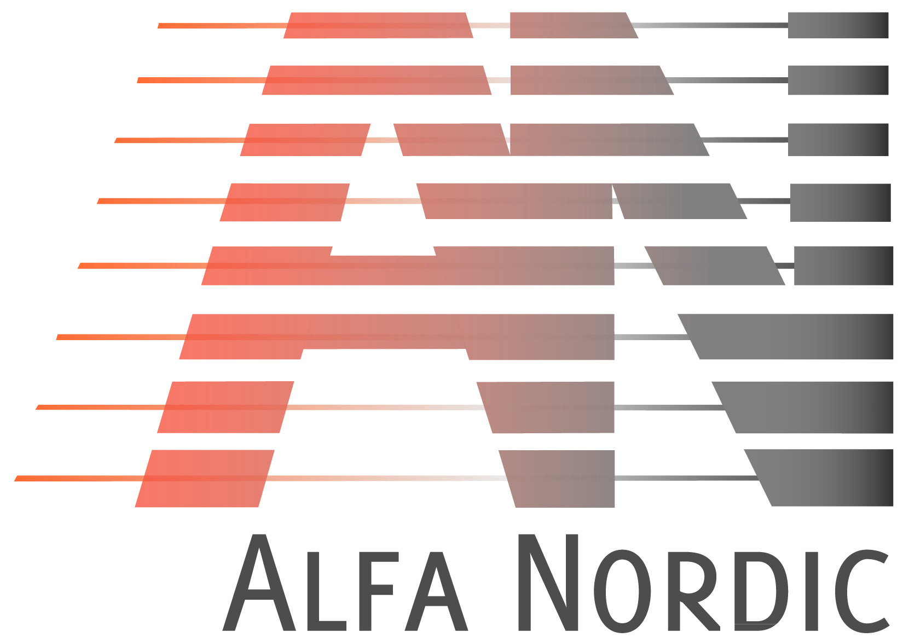

***NB 328***

**NB Series – Technical Dimension Sheet**

**_________________________________________________________**

Alfa Nordic produces a comprehensive range of BPHE featuring different sizes, plate counts, thermal characteristics and mechanical configuration. The NB series can be adapted to numerous standard applications while working across a wide capacity and fluid range. Though, it always offers the most reliable and economic solution for your demanding heat transfer duty.

**Dimensions [mm]**

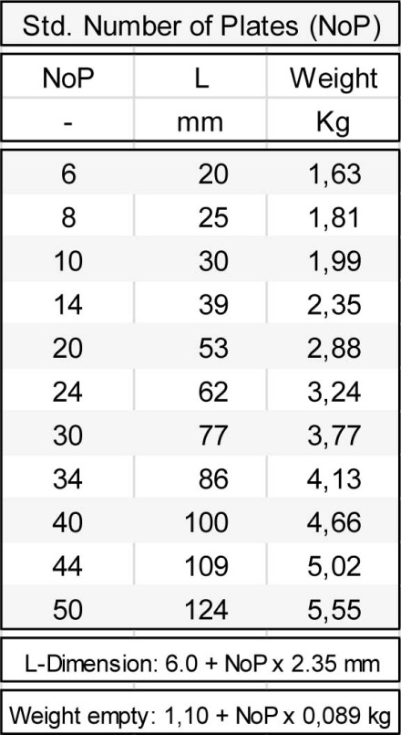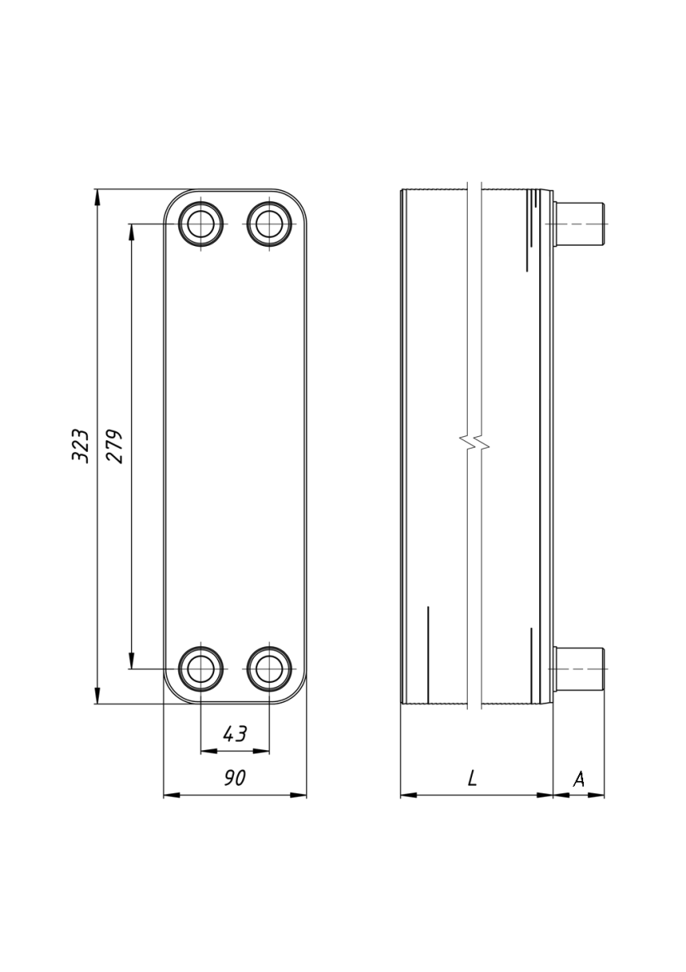

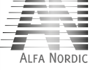

Place for label

**Technical data:**

Max. allowable Pressure at 200°C

(design pressure, see graph): 31 bar

Test Pressure (PT): 55 bar

Min./Max. Temperature: -200 / +200°C

Min./Max. Number of Plates: 6/50

Materials, product wetted parts: AISI 316L

Materials, others: AISI 304

Brazing Filler Material: Pure Cu

(99,99% - oxygen free)

NB328 – high pressure drop plate

**BPHE plate configuration:**

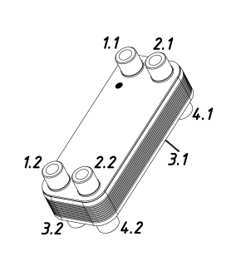

* Dot on BPHE marks entrance of the primary channel

*

Customized Configuration:

Multi-pass, other flow variants, additional connections, any types & sizes (dimension A depends on the type of connector), non-std. no. of plates and many more

Standard Configuration:

Single-pass, all 4 connections on Front, primary fluid left hand (1.1, 1.2), secondary fluid (2.1, 2.2)

Third Party Approval: PED – 97/23/EC, Fluid Group: II, CE-1407, other certifications on request

***NB 328***

**NB Series – Technical Dimension Sheet**

**___________________________________________________________**

Offered connectors are available in different sizes: from Dn10 up to Dn25.

Ordering BPHE with special, connectors may require additional time due to development and production of these nonstandard connectors.

Distance between connectors is adjustable using special transitions to be able to meet other HE manufacturer standards.

Both BPHE channels are designed for the same pressure and temperature loads.

Certified pressure – 31 bar.

Application – fluid group I and II according to Pressure Equipment Directive (PED – 97/23/EC).

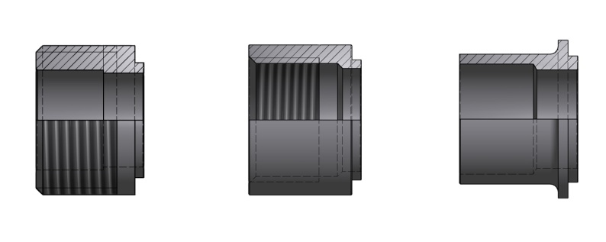

Universal (External

threaded and for soldering

Internal

threaded

Soldering

More connections are available on special request

**Available connector types**

Material Disclaimer: The information and recommendations contained in this printing are presented in good faith. However, they shall serve as non-binding description only. Alfa Nordic makes no representations or warranties as to the completeness or accuracy of the content and disclaims any responsibility thereof.

Please verify availability of the optional accessories for a given model.

**Optional accessories for NB 328**

* Heat insulation (polyurethane box);
* Stud bolts (M8 - M12);
* Removable gland nut connectors;
* Other solutions on special request after Alfa Nordic approvement may be applied.